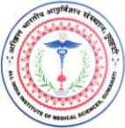
अखिल भारतीय आयुर्विज्ञानसंस्थान(एम्स), गुवाहाटी

All India Institute of Medical Sciences, Guwahati
Silbharal, Changsari, Kamrup, Assam - 781101
_______________________________________________________________________________________________

FORMAT FOR SUBMISSION OF CLAIMS FOR LEARNING RESOURCE ALLOWANCE (LRA) FOR THE YEAR 2022-23

Name of the Faculty/Officer :

Designation :

Department :

Date of Joining :

Sl. No.

Name of the item purchased/ short term course

Invoice No. & date

Amount in INR

Transaction details, if purchased online

Certified that all these above items are admissible under the LRA and used by me as resource material for learning.

Date:

Signature of the Faculty/Officer

