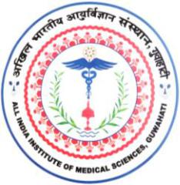
अखिल भारतीय आयुर्विज्ञानसंस्थान(एम्स), गुवाहाटी

All India Institute of Medical Sciences, Guwahati
स्वास्थ्य और पररवार कल्याण मंत्रालय,भारत सरकार केतत्वावधान मेंएकवैधाननकननकाय

(A statutory body under the aegis of Ministry of Health and Family Welfare, GoI)

_________________________________________________________________________________________________

PROFORMA FOR THE TAKING PRIOR PERMISSION BY GOVERNMENT SERVANTS FOR PRIVATE VISITS ABROAD

Part A – To be filled by the Government servant applying for visit abroad

- Name and Designation:

- Pay:

- Ministry / Department:

- Passport No:

- Details of Private foreign travel to be undertaken:

Period of travel

Name of foreign countries to be visited

Purpose

Estimated
expenditure (travel, boarding, lodging, visa, misc, etc)

Source of funds

- Details of Private foreign travel undertaken during the last four years.

Period of travel

Name of foreign countries visited

Purpose

 | Signature
Date: ..........................................................
 | ..................................................
( | )
 | Name and Designation

__________________________________________________________________________________________

Changsari, Assam PIN - 781101

